# RCS VISION AI - Automated Object Detection and Tracking System

## Overview

This project is an AI-powered video processing system that detects and tracks objects in video footage using YOLO models and DeepSORT tracking. It also includes Optical Character Recognition (OCR) for detecting and extracting text from number plates. The system is designed to identify various objects like cars, pedestrians, garbage, and parking violations.

## Features

* **Object Detection:** Uses YOLO models to detect various objects like cars, pedestrians, streetlights, garbage, and more.
* **Illegal Parking Detection:** Identifies cars parked illegally based on overlapping regions.
* **Number Plate Recognition:** Uses OCR (EasyOCR) to extract and display text from detected number plates.
* **Car Color Detection:** Determines the most common color of a detected vehicle.
* **DeepSORT Tracking:** Assigns unique IDs to detected objects and tracks them throughout the video.
* **Report Generation:** Creates a CSV file with details of detected objects, timestamps, and status.
* **User Interface:** A simple Gradio-based web app for selecting videos and objects to detect.

## Installation

### Prerequisites

Ensure you have the following installed:

* Python 3.x
* pip (Python package manager)
* CUDA (if using GPU acceleration)

### Required Libraries

Install the required dependencies using the following command:

pip install opencv-python ultralytics gradio easyocr deep_sort_realtime numpy webcolors

## How to Use

### Running the Application

Script to run -> testing.py

**Weights imports:**

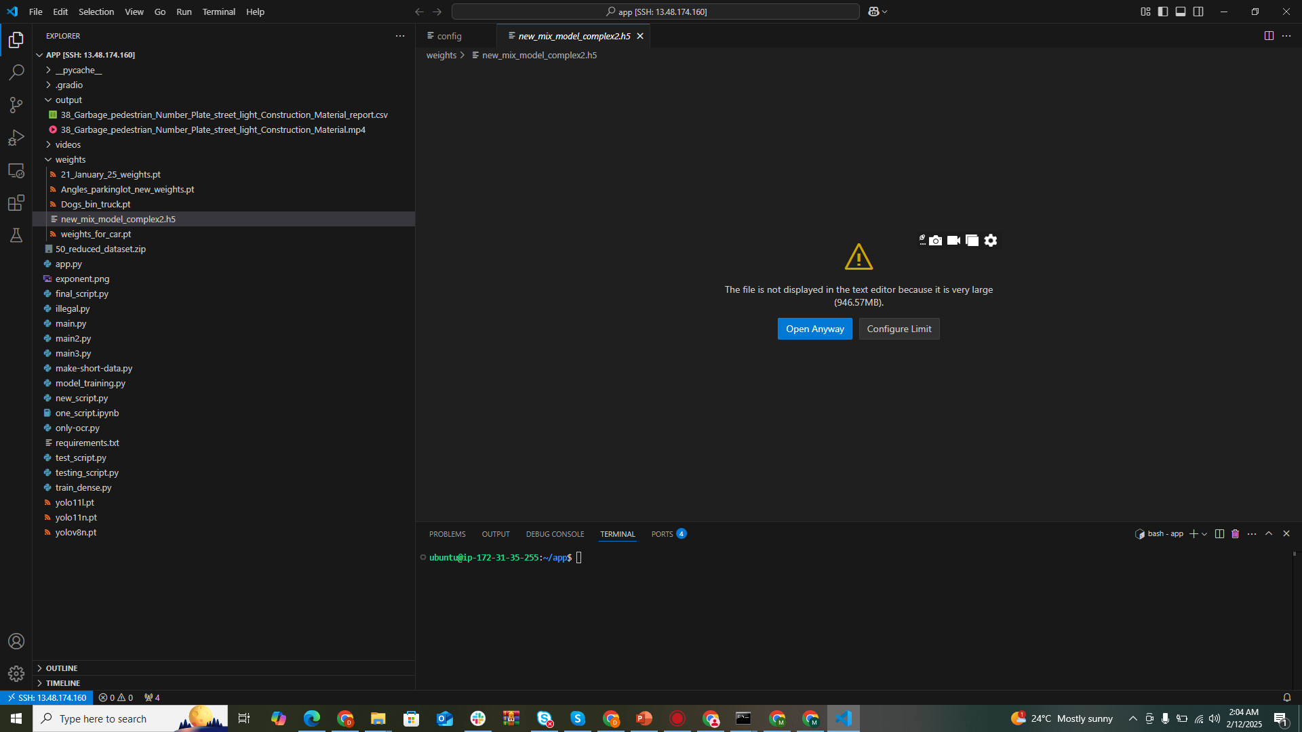

**Prepare Video Files:** Place input videos in the videos/ directory.

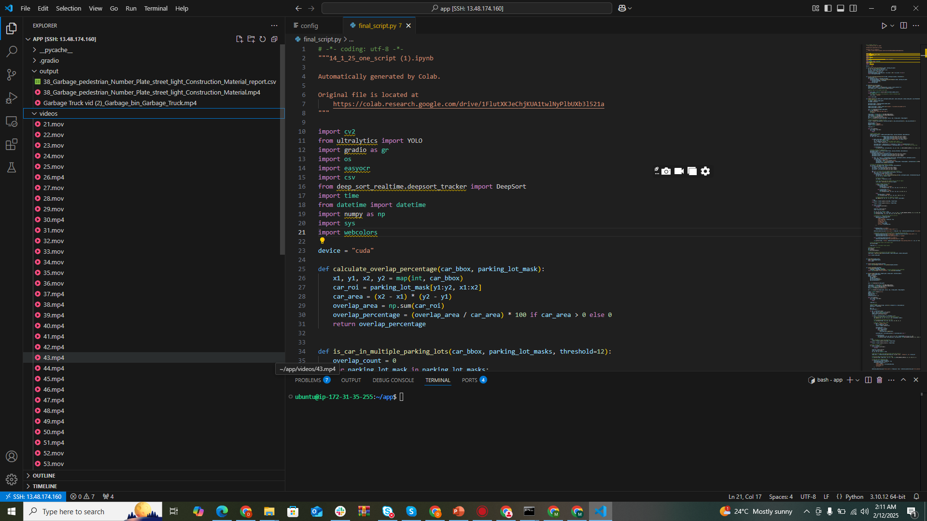

**Run the Script:** Execute the following command to start the application:

python final_script.py

**Select Options in the UI:**

* + - * Choose a video from the dropdown menu.
      * Select objects you want to detect (e.g., illegal parking, number plates, garbage, etc.).
      * Click "Submit" to process the video.

**Download Results:**

* The processed video with object detection overlays will be available for download.
* A CSV report containing detection details will also be generated.

## Output Files

**Processed Video:** Located in the output/ folder.

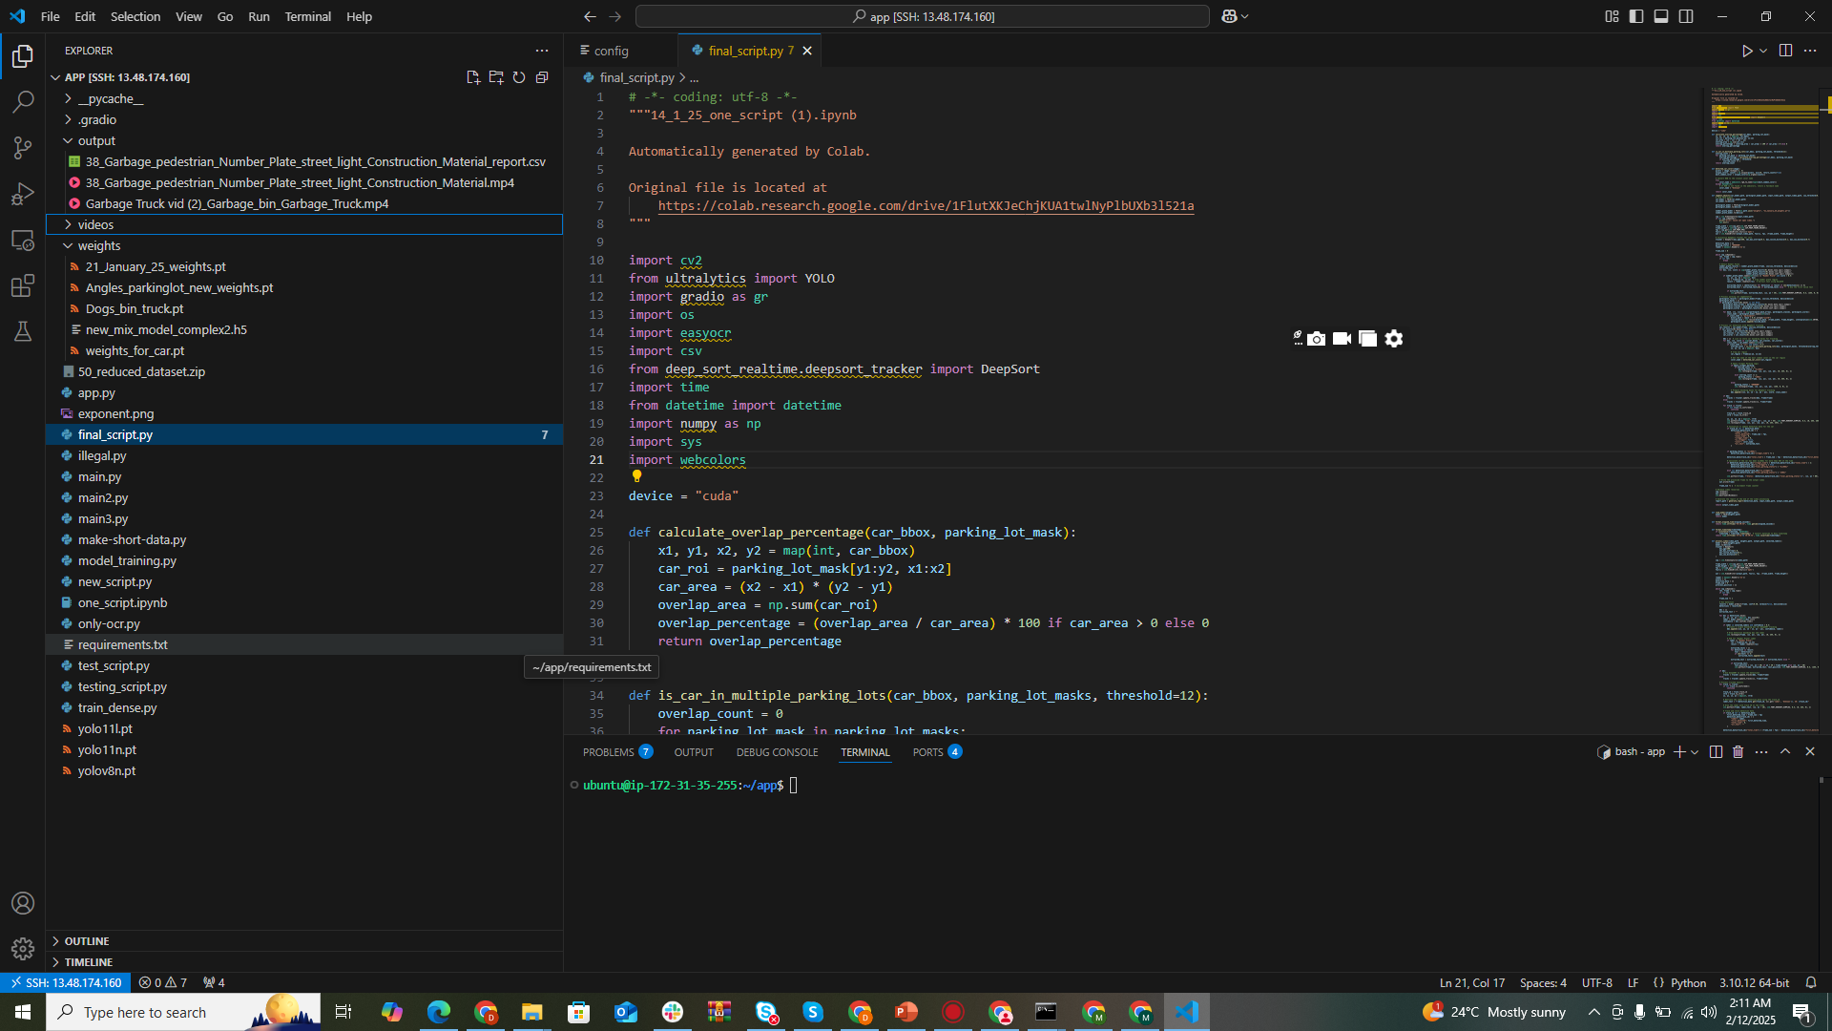

**CSV Report:** Includes details such as detection timestamps, labels, parking status, and number plate text.

## Supported Object Labels

* Garbage
* Number Plate
* Pedestrian
* Street Light
* Construction Material
* Water Spilled
* Illegal Parking
* Dogs
* Garbage Truck
* Garbage Bin

Weights_for_car : Pretrained models for Pedestrian, Car detection

21_Januarary_25_weights : Garbage, Place , Street Light, Construction material,

Angles_parkinglot_new_weights : Illegal Parking Segmentation

digit_detection : detecting digits on plate

Dogs_bin_truck : Detection of Dogs, garbage_bin, truck